Holy Rosary CVA
Science | Animals and Living things | KS1 | Lent 1
What will we explore..?
Humans
Human beings |  | - We are called humans  - We are from the family of animals called mammals
Basic parts of the human body |  | Hair, head, ears, eyebrows,  eyes, nose, mouth, chin, neck, shoulder, chest, elbow, arm, wrist, hand, tummy, knee, leg, ankle and foot
There are 5 basic human senses |  | Touch, taste, smell, sight and hearing
How do we touch? | 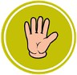 | We touch using our skin (usually our hands)
How do we taste? |  | We taste by putting something in our mouth
How do we smell? |  | We smell by using our nose
How do we see? |  | We see by using our eyes
How do we hear? | 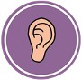 | We hear by using our ears
Animals
6 types of animals |  | - Invertebrates; crab, jellyfish, worm  - Fish; goldfish, cod, shark  - Amphibians; frog, toad, newt  - Reptiles; snake, crocodile, lizard  - Birds; sparrow, chicken, owl  - Mammals; human, dog, lion
Carnivores |  | - Animals that eat other animals are called  carnivores; human, pig, rat
Herbivores |  | - Animals that eat plants are called herbivores; cow, sheep, rabbit
Omnivores |  | - Animals that eat both plants and other animals are called omnivores; lion, tiger, brown bear
What? (Key Vocabulary)
Spelling | Definition/Sentence
Pet | A friendly animal trained to live with humans
Fish | An animal with gills and fins that lives in water
Birds | An animal with feathers, wings and a beak that is usually able to fly
Mammals | An animal that feeds its young with milk from the mother and has skin usually more or less covered with hair
Reptiles | An animal which has dry, scaly skin and lays eggs on land
Invertebrates | Animals with no back bone
Amphibians | An animal which can live on land or in water

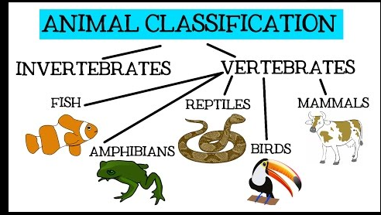

Key Knowledge
- How to classify animals by what they eat
- Know a Human is an animal
- Identify things as living or non-living
- Classify a variety of animals
- Classify a Human as a Mammal
- Know how to link the correct part of the human body to each sense

What do you know..?

- Can organise different animals into groups?
- Can you link animals using the food they eat?
- Can you sort things into living and non-living?
- Can you draw a human body and label the senses.

