Holy Rosary CVA
Geography Driver: Why can’t penguins live near the equator? | Human and Physical | KS1 | Advent 2
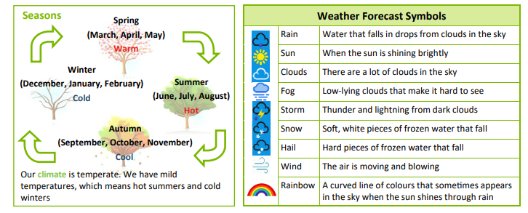
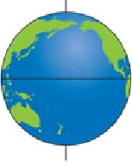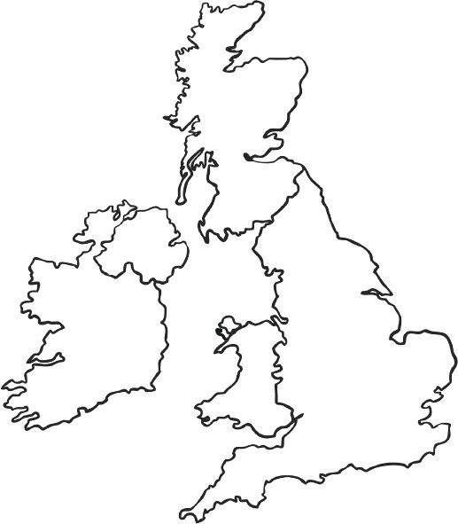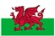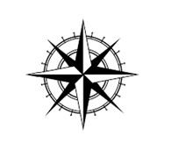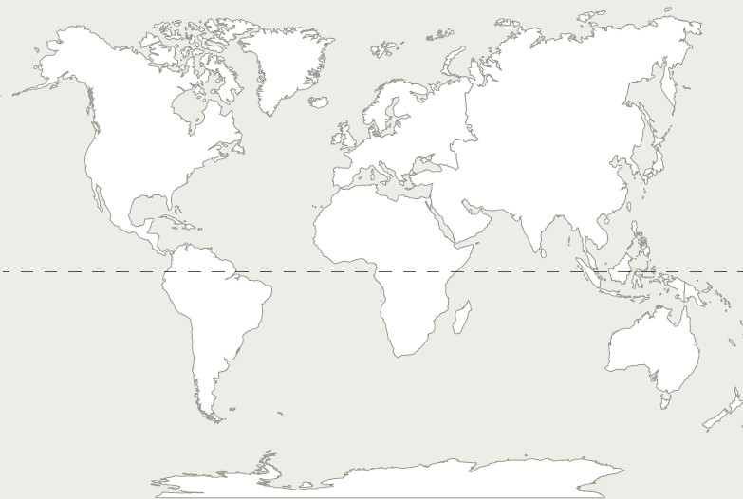
Equator
As you travel towards the equator the climate gets warmer
The climate gets cooler as you move away from the equator
In the UK, the North is colder than the South and the West is wetter than the East
South Pole
The Equator
The Equator is an imaginary line around the middle of the Earth at an equal distance
from the North and South Poles
North Pole
Know the location of hot and cold areas in relation to the Equator and North and South Poles

Know the differences between the physical features of places on the Equator and the North and South Poles.

Know the effects humans are having on places on the Equator and the Poles.

Know how to use world maps, atlases and globes to identify the United Kingdom compared to the poles and equator

Know how to use simple compass directions (North, South, East and West) and locational and directional language to describe the location of features on a map

What do you know..?
- Can you colour a map of the world to show which places are hotter than others?
- Can you draw/label/describe what you might see in places near the equator/north pole/south pole?
- Can you find the UK on a map?
- Can you use the words North/South/East and West to describe where places are?

WALES Cardiff
London
Belfast
ENGLAND
NORTHERN IRELAND
Edinburgh
South
SCOTLAND
East
West
Capital Cities in the United Kingdom
North
Continents are a group of 7 areas of land on Earth that are joined
Oceans are 5 large areas of water across the world
SOUTHERN OCEAN

ANTARCTICA
NORTH
AUSTRALIA
INDIAN
OCEAN
SOUTH
AMERICA
OCEAN
AFRICA
OCEAN
ATLANTIC PACIFIC
ASIA
EUROPE
NORTH
AMERICA
Continents and Oceans
ARCTIC OCEAN

What do you know..?
- Can you describe how a seed grows into a plant?
- Can you describe what a plant needs to stay healthy?
- Can you name at least 4 different types of plant?
- Can you draw the life cycle of a plant?
- Can you draw two different types of seeds?

What do you know..?
- Can you describe how a seed grows into a plant?
- Can you describe what a plant needs to stay healthy?
- Can you name at least 4 different types of plant?
- Can you draw the life cycle of a plant?
- Can you draw two different types of seeds?
Core Knowledge
Core Knowledge
What do you know..?
- Can you describe how a seed grows into a plant?
- Can you describe what a plant needs to stay healthy?
- Can you name at least 4 different types of plant?
- Can you draw the life cycle of a plant?
- Can you draw/name two different types of seeds?

Core Knowlege
•know and explain how seeds and bulbs grow into plants.
•know what plants need in order to grow and stay healthy (water, light & suitable temperature).
•identify and name plants and animals in a range of habitats.
•recognise some seeds and associate them with trees, e.g., horse chestnut.
•know which animals are woodland creatures

Core Knowledge
What do you know..?
- Can you describe how a seed grows into a plant?
- Can you describe what a plant needs to stay healthy?
- Can you name at least 4 different types of plant?
- Can you draw the life cycle of a plant?
- Can you draw two different types of seeds?

Core Knowledge

