Holy Rosary CVA
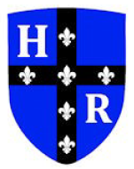
Key Question: How can we see things? | Light | LKS2 | Advent 2
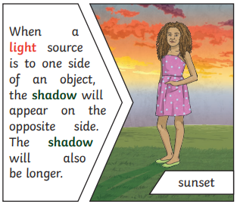
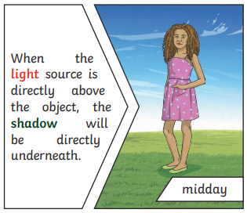
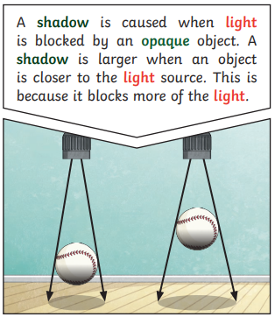
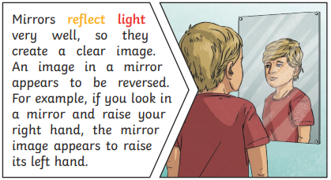
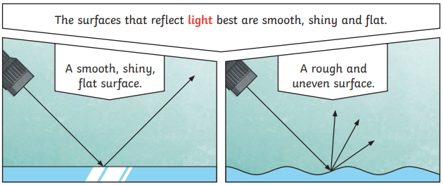
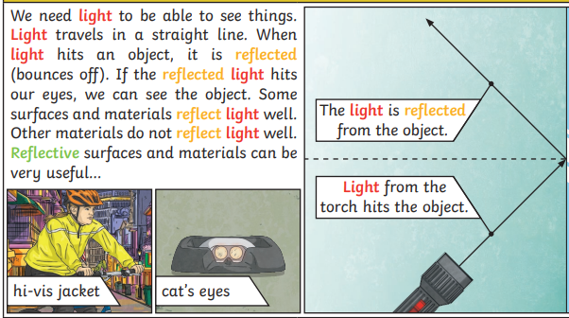
Vocabulary
light | A form of energy that travels in a wave from a source.
Light source | An object that makes its own light.
Dark | Dark is the absence of light.
Reflection | The process where light hits the surface of an object and bounces back into our eyes.
Reflect | To bounce off.
Reflective | A word to describe something which reflects light well.
Ray | Waves of light are called light rays. They can also be called beams.
Blocked | When light can not penetrate an object.
Shadow | A dark area or shape produced by something coming between rays of light and a surface.

