Holy Rosary CVA
Key Question: Is there anybody out there? What is our solar system actually like? | Earth & Space | UKS2 | Advent 2

Vocabulary
Our Solar System
The Sun | A huge star that Earth and the other planets in our solar system orbit around.
star | A giant ball of gas held together by its own gravity
moon | A natural satellite which orbits Earth or other planets
satellite | Any object or body in space that orbits something else, for example: the Moon is a satellite of Earth
planet | A large object, spherical or nearly spherical, that orbits a star
spherical | 3D round shaped, in the shape of a ball
spherical bodies | Astronomical objects shaped like spheres
Movement of the Earth
orbit | To move in a regular, repeating curved path around another object
rotate | To spin, e.g. Earth rotates on its own axis
axis | An imaginary line that a body rotates around, e.g. Earth’s axis (imaginary line) runs from the North Pole to the South Pole.
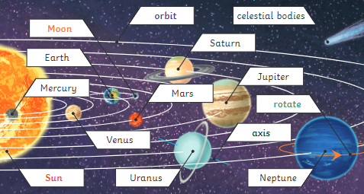

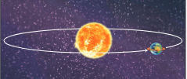

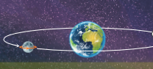

Pre/Post Quiz (complete separately):

- The Earth a) rotates
b) vibrates
c) orbits
d) is spherical

- The moon is a satellite.
True/False

- Put these in order:
- It only seems to us that the Sun moves because of the movements of Earth.
- However, the Sun does not move at all.
- It appears to us that the Sun moves across the sky during the day.
- In conclusion, as the Earth rotates, the Sun appears to move across the sky (from our perspective).

- Can you name each of the planets?

What do you know..?
- Can you describe how a seed grows into a plant?
- Can you describe what a plant needs to stay healthy?
- Can you name at least 4 different types of plant?
- Can you draw the life cycle of a plant?
- Can you draw two different types of seeds?
What do you know..?
- Can you describe how a seed grows into a plant?
- Can you describe what a plant needs to stay healthy?
- Can you name at least 4 different types of plant?
- Can you draw the life cycle of a plant?
- Can you draw two different types of seeds?
Core Knowledge
Core Knowledge
- The Moon orbits the Earth
- The Earth orbits the Sun as the 3rd planet in the Solar System
- The Earth rotates on its axis meaning it is daytime in areas in sunlight and night in the dark
- As the Earth rotates, the Sun appears to move across the sky, from our perspective.
- The Solar System consists of the Sun in the centre, orbited by spherical planets: Mercury, Venus, Earth, Mars, Jupiter, Saturn, Uranus and Neptune (in that order)

Core Knowlege
Core Knowledge
What do you know..?
- Can you describe how a seed grows into a plant?
- Can you describe what a plant needs to stay healthy?
- Can you name at least 4 different types of plant?
- Can you draw the life cycle of a plant?
- Can you draw two different types of seeds?

Core Knowledge

