Holy Rosary CVA
Science Driver: | Forces and Magnets | LKS2 | 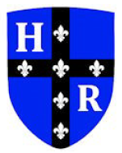  Lent 2
Key vocabulary | Definition
Friction | A force that acts between two surfaces or objects that are moving across each other
Attract | Attraction is a force that pulls objects together.
Repel | Repulsion is a force that pushes objects away from each other.
Positive  &  Negative | Magnets have their own poles that point towards the earth’s poles. The south pole is positive and the north is negative
Pole | North and South poles are found at different ends of a magnet.
Magnetic | Objects that are attracted to a magnet are magnetic.
Magnetic field | The area around a magnet where there is a magnetic force, which pulls an object towards the magnet.

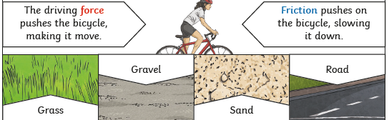
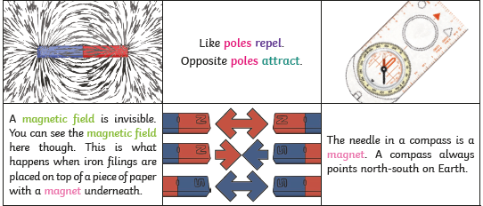
Core Knowledge
- Magnetism and friction are different forces.
- Magnets have two poles.
- Only some metals are magnetic, but all magnets are metal.
- There are different types of magnets, including electromagnets.
- Different surfaces create different amounts of friction, the amount caused depends on the roughness of the surface and the object and the force between them.

